**CR1350 Assignment #1**

**Due:** May 30th before 11:59PM.

**IMPORTANT:** The Dropbox will close at 12AM and no assignments will be accepted after that!

Answer all questions on the document!

DO NOT CREATE YOUR OWN! Marks will be lost!

**Question 1**

Identify and name an advantage for each of the following topologies.

a)

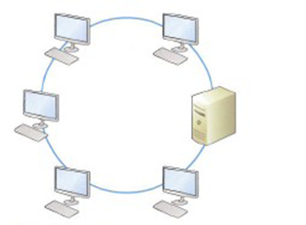

|  |
| --- |
|  |

b)

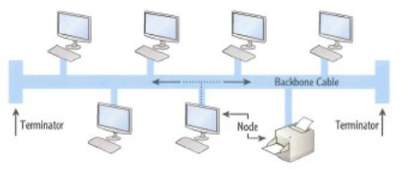

|  |
| --- |
|  |

c)

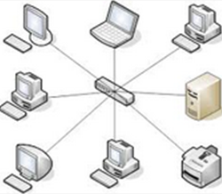

|  |
| --- |
|  |

**Question 2**

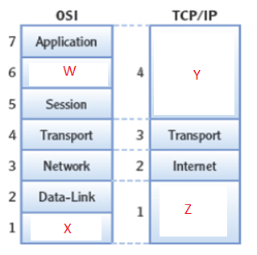

Identify the missing layers.

|  |
| --- |
|  |

**Question 3**

Identify what the numbers stand for and what OSI Model layer would be involved in processing these numbers.

(a) works with numbers like 53, 80

|  |
| --- |
|  |

(b) works with ’10.200.100.50’

|  |
| --- |
|  |

(c) works with ‘A1B99C1F00C3’

|  |
| --- |
|  |

**Question 4**

**Application Protocols.**

(a) Which TCP/IP application protocol would be used to maintain domain names to the IP address registry?

|  |
| --- |
|  |

(b) Which TCP/IP application protocol would be used to transfer files?

|  |
| --- |
|  |

(c) Which TCP/IP Transport protocol is the most reliable?

|  |
| --- |
|  |

(d) Which TCP/IP internet protocol discover an IP address from a provided MAC address?

|  |
| --- |
|  |

**Question 5**

**Note:** *One number is an INVALID IP so indicate it as invalid.*

Based only on the IP numbering scheme, Identify each of the following IP addresses as Class – A, Class – B, Class – C , or Invalid IP Address

195.140.140.1

|  |
| --- |
|  |

10.200.4.1

|  |
| --- |
|  |

200.300.255.4

|  |
| --- |
|  |

170.150.150.1

|  |
| --- |
|  |

**Question 6**

Based on IP address and subnet mask only, identify the network IDs of each of the following.

Are two or more of the numbers below on the same network? If there is, what ones are they?

173.40.60.33 Mask 255.255.0.0

|  |
| --- |
|  |

173.30.105.33 Mask 255.255.0.0

|  |
| --- |
|  |

173.40.107.44 Mask 255.255.0.0

|  |
| --- |
|  |

173.30.107.33 Mask 255.255.0.0

|  |
| --- |
|  |

**Question 7**

Name a limitation of the Private IPv4 addressing?

|  |
| --- |
|  |

**Question 8**

Use your lab computer for the following activities. Take a screenshot of each of the commands issued and corresponding output. (Include three screenshots.)

a) Use the correct command to display the IPv4 address of your host computer.   
 **Screenshot Required**

b) Use the correct command to test connectivity to the computer with IP address 192.168.200.110  
**Screenshot Required**

c) Use the correct command to find the IP address for the web server netflix.com.  
 **Screenshot Required**

**Question 9**

Use ANDing to determine the network address of each of the following and identify the ones that are on the same network. (Circle or highlight them.)

1. IP Address 172.24.192.232 10101100 00011000 11000000 11101000

Subnet Mask 255.255.255.0 11111111 11111111 11111111 00000000

|  |
| --- |
|  |

Network Address:

1. IP Address 172.23.5.15 10101100 00010111 00000101 00001111

Subnet Mask 255.255.224.0 11111111 11111111 11100000 00000000

|  |
| --- |
|  |

Network Address:

1. IP Address 10.151.10.121 00001010 10010111 00001010 01111001

Subnet Mask 255.255.255.252 11111111 11111111 11111111 11111100

|  |
| --- |
|  |

Network Address:

1. IP Address 172.16.4.100 10101100 00010000 00000100 01100100

Subnet Mask 255.255.0.0 11111111 11111111 00000000 00000000

|  |
| --- |
|  |

Network Address:

1. IP Address 172.16.4.99 10101100 00010000 00000100 01100011

Subnet Mask 255.255.0.0 11111111 11111111 00000000 00000000

|  |
| --- |
|  |

Network Address:

1. IP Address 172.16.0.1 10101100 00010000 00000000 00000001

Subnet Mask 255.255.0.0 11111111 11111111 00000000 00000000

|  |
| --- |
|  |

Network Address:

1. IP Address 172.17.4.1 10101100 00010001 00000100 00000001

Subnet Mask 255.255.0.0 11111111 11111111 00000000 00000000

|  |
| --- |
|  |

Network Address:

**Question 10**

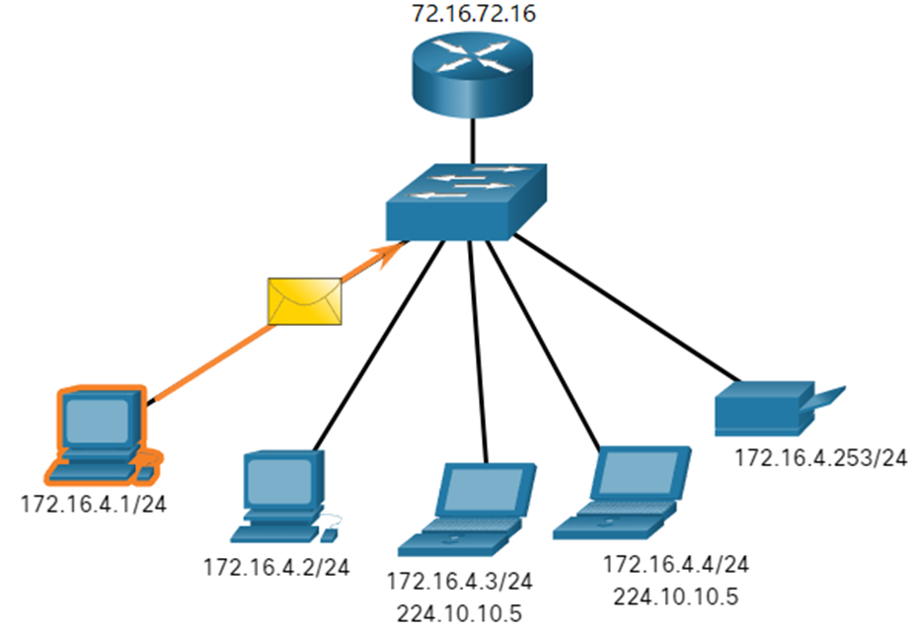

**NOTE:** */24 means it’s a class C subnet*

1. The source IPv4 address is 172.16.4.1 and the destination IPv4 address is 224.10.10.5. Which devices will receive the packet? (Give the IP address and the device type.)

|  |
| --- |
|  |

1. The source IPv4 address is 172.16.4.1 and the destination IPv4 address is 172.16.4.253. Which devices will receive the packet?

|  |
| --- |
|  |

1. The source IPv4 address is 172.16.4.1 and the destination IPv4 address is 255.255.255.255. Which devices will receive the packet?

|  |
| --- |
|  |

1. The source IPv4 address is 172.16.4.1 and the destination IPv4 address is 172.16.4.3. Which devices will receive the packet?

|  |
| --- |
|  |

**Question 11**Convert the IP into short and compressed forms.

1. 2013:ef12:0123:4567:89ab:cdef:0000:0001

Omit leading zeroes:

|  |  |  |  |  |  |  |  |  |  |  |  |  |  |  |
| --- | --- | --- | --- | --- | --- | --- | --- | --- | --- | --- | --- | --- | --- | --- |
|  |  |  |  |  |  |  |  |  |  |  |  |  |  |  |

Compressed format:

|  |
| --- |
|  |

1. 2001:0db8:0000:1234:5678:9101:1112:1113

Omit leading zeroes:

|  |  |  |  |  |  |  |  |  |  |  |  |  |  |  |
| --- | --- | --- | --- | --- | --- | --- | --- | --- | --- | --- | --- | --- | --- | --- |
|  |  |  |  |  |  |  |  |  |  |  |  |  |  |  |

Compressed format:

|  |
| --- |
|  |

1. 2001:db8:2233:4455:6677:0000:0000:0101

Omit leading zeroes:

|  |  |  |  |  |  |  |  |  |  |  |  |  |  |  |
| --- | --- | --- | --- | --- | --- | --- | --- | --- | --- | --- | --- | --- | --- | --- |
|  |  |  |  |  |  |  |  |  |  |  |  |  |  |  |

Compressed format:

|  |
| --- |
|  |